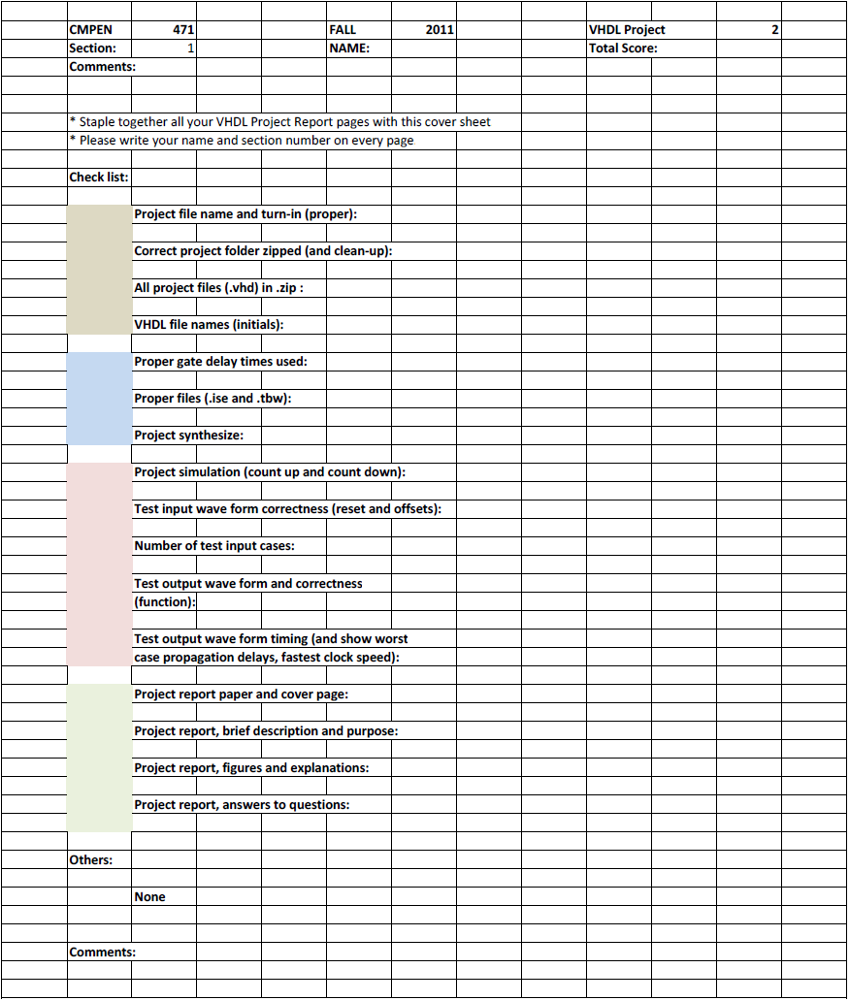
Erik Arfvidson
5

Erik Arfvidson
10/11/2012
Lab5

Project Report5

Purpose and Description

Design, implement, simulate, and debug Simple Microcontroller with 4 instructions and 3 addressing modes. Use ROM of Project 3 and RAM of Project 4.

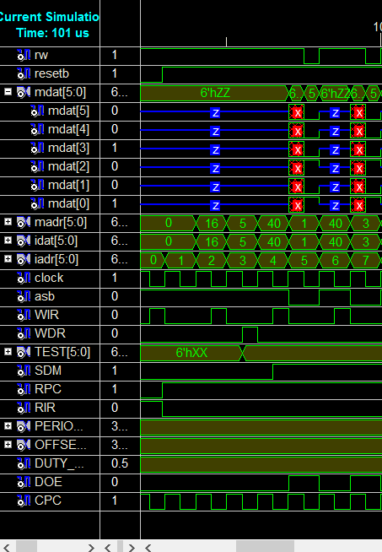
Simulations 1

The first command is a noop followed by Load 5 to the register and then Storing 5 into the memory address one and three

Simulation 2

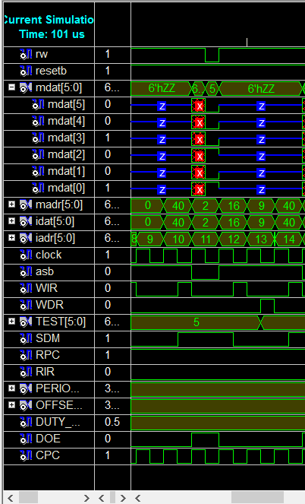

The first instruction in this segment is a noop followed by a store 5 to memory address 2. The last instruction is Load Immediate number nine to the register.

Simulation3

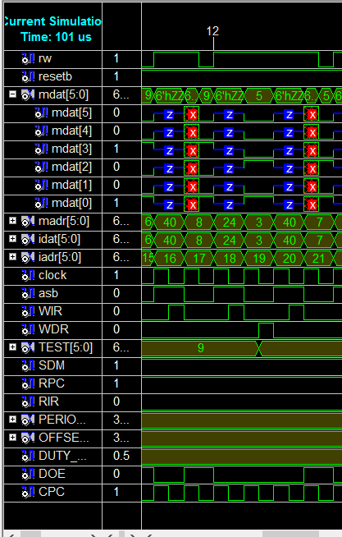
This Simulation is pretty Straight forward. The first instruction is Store 9 to memory Address 6 and 8. Then we load memory address 3 to the register file

Simulation4
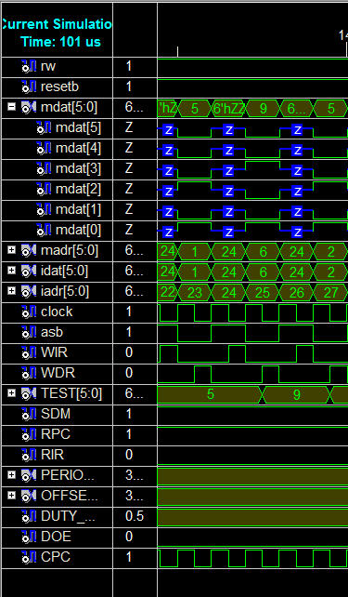
In this simulation we store the value of memory addres three and store it to 7. Then We load memory address 1 to the register file. Then we load Memory Address 6, followed by another load of 2.

Simulation5
This is my last simulation of all the instructions given in the assignment. We first load 7 then 3 and then 8 and we finalize with a noop. I didn’t include the noop part because I found it to be unnecessary.

Testbench1

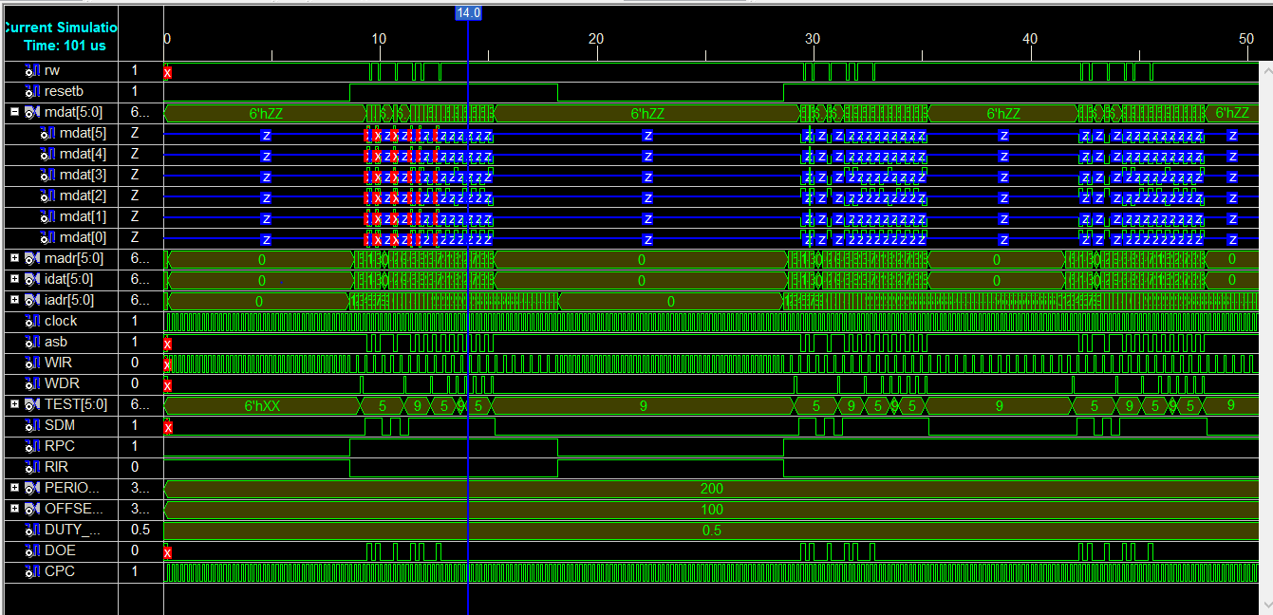
Runs program once and then reset and run it again

